July 8th, 2007
Hi


Sian – Congratulations on your graduation! And a ‘first’ (which I assume means first class honours) is pretty good. Well done!

Not much else to write about really. Last Sunday, as I think I mentioned in the last letter, was the 10th anniversary of handover. There was an early morning ceremony at Bauhinia Square. The parachute display that had been postponed because of bad weather was held on Monday (which was the holiday, given that Sunday is already a holiday).
I only did exercise for three days this week. I was just too tired, so decided to take a week off. However, in those three days, I did 6 km swimming.
On Thursday, I went to the dermatology clinic for a regular check-up. They did a liquid nitrogen treatment for several small areas spots on the hands. These were probably just dry skin or pimples but as the treatment is so simple and quick, it was done just in case.
Watched part of the test yesterday between Australia and South Africa. The Springboks were ahead 17 – 0 after just 15 minutes but that was all they scored, eventually going done 25 – 17. An interesting comment by a commentator after the Springboks first converted try which occurred after seven minutes, that is 7 points after 7 minutes on the 7th day of the 7th month of the 7th year (2007) – 7-7-7-7-7!
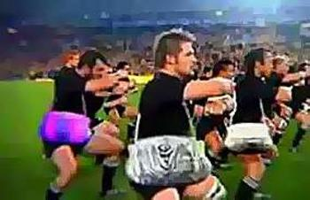
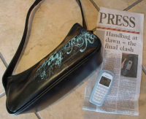
This letter is written over the letter for this week last year. In it, I write about the handbag incident in a Christchurch pub in which Tama Umaga sloshed a drunk, misbehaving teammate with a woman’s handbag he picked up from a table. Remember the incident? Then there was the handbag ad shown on Australian TV to advertise the upcoming Australia-NZ tri-nations match. In that letter, I included the photographs shown above and decided to leave them, as they are quite amusing.
That’s it for now.
Cheers

